**CNFS**

**Computer Network File**

**System**

**Whitepaper**



World's first blockchain technology protocol which provides controllable risk, complete life cycle security and privacy protection, high storage scalability, high data compatibility and high data computing efficiency

Table of Contents

01

Technology and Industry Overview

1.1 Blockchain Technology

1.2 Market Prospect

1.3 Existing Problems

02

CNFS Project Introduction

2.1 Technology Introduction

2.2 Distributed Storage

2.3 Distributed Computing

2.4 Consensus Protocol

03

Business Model

3.1 Token Mechanism

3.2 Benefits of Investment

3.3 Community

04

Core Advantages

05

Routines

06

Disclaimers



Abstract

Technology is almost the only power in the process of human civilization that can achieve superimposed progress. History may repeat, but technology will always move forward. The vision of the Internet is interconnected, decentralized and discrete. However, due to the rise of distributed computing, the Internet has become more and more centralized. As the era of blockchain 3.0 approaches, blockchain application can go far beyond the scope of finance, expanding many fields such as identity authentication, justice, audit, logistics, medical care, energy, etc., becoming the lowest level protocol of the future Internet. However, most of the current Data is stored in the cloud server cluster of central enterprises. Data verification and supervision become the most resource-consuming and complex problems to solve when Data is stored in a third party that is not fully trusted. At the same time, when the information resources are aggregated on the distributed computing platform, problems like platform monopoly, opaque operation, data loss, data untrustworthiness and privacy leakage, and Blockchain development will be significantly restricted.

CNFS (Computer Network File System) is the world's first secure, controllable and content-addressable peer-to-peer hypermedia distribution protocol. It aims to provide content-based addressing services, replace HTTP protocol clusters, connect and integrate storage and computing resources. Besides, it offers open, fair and manageable distributed storage services. Relying on the CNFS protocol system builds a distributed storage cluster with high throughput, provides limited centralized distributed storage services and builds the next generation of the civil, political, and commercial integrated license-free chain.

CNFS consists of a new set of Internet application layer protocols for modern Internet resources and facilities, a redefined cloud services, edge computing, Blockchain, data distribution, data fusion and distributed storage. It's the world's first blockchain technology protocol that provides controllable risk, complete life cycle security and privacy protection, high storage scalability, high data compatibility and high data computing efficiency.

01

Technology and Industry Overview

* 1. Blockchain Technology

Blockchain technology is the next generation of disruptive technology after the steam engine, power and Internet. If the steam engine has released people's productivity, the power has solved people's basic living needs, and the Internet has completely changed information transfer methods. As a machine designed for trust, the Blockchain may completely change the value transfer of the whole human society. The significance of Blockchain is that it can build a more reliable internet system and fundamentally solve the fraud and rent-seeking phenomenon in value exchange and transfer. With the popularization of blockchain technology, the digital economy will be more authentic, and the economic society will become fairer and more transparent.

As the birthplace of Internet technology, the United States has invested heavily in blockchain technology and applications. In 2017, at least eight states in the United States proposed bills to stimulate the development and application of blockchain technology. In February 2018, the U.S. House of Representatives held two consecutive hearings on Blockchain to explore new applications of blockchain technology. The U.S. state department emphasizes that blockchain technology can improve transparency and solve corruption, fraud. The U.S. Treasury is conducting pilot programs to determine whether blockchain technology can be used for the supply chain management. It has also taken measures to improve relevant laws on "anti-money laundering / combating terrorist financing (AML / CFT)" based on cryptocurrency and formed public-private partnerships (PPPs) with financial institutions to share information. South Burlington, Vermont, will utilize blockchain technology to record real estate transactions. California legislators have submitted a bill that the state's electronic records law should admit blockchain signatures and smart contracts. New York State Power Company TransActiveGrid proposed a new P2P distributed micro electric network based on Blockchain. Through the Blockchain, a microgrid network will be established to improve the utilization rate of clean energy. The remaining electricity is recorded on the Blockchain and can be sold to neighboring users through smart contracts.

In January 2016, the U.K. government released a report called "Distributed Ledger Technology: Beyond Blockchain". The report points out that blockchain technology has great potential in changing public and private services. In addition to creating a public platform based on Blockchain to provide services for the whole people and society, the British government also plans to develop a system that can be a bridge between the government and public institutions. The Japanese government strongly supports blockchain technology and the cryptocurrency industry and has established the first blockchain industry organization - Japan Blockchain Association (JBA) and blockchain cooperation. Russia is vigorously promoting the construction of blockchain infrastructure. Sberbank, Russia's largest bank, cooperates with the government to transfer and save files with Blockchain, which has become a real application case of Blockchain. Canada has a vast blockchain entrepreneurial community, which brings together many top blockchain talents, including Vitalik Buterin, the founder of Ethereum. The Canadian Securities Regulatory Commission (CSA) recently launched a new "Fintech Sandbox" program to promote Canada's blockchain industry development.

Blockchain technology originated from the open-source community and has grown fast in the community. Since then, it has gradually attracted the attention of financial institutions, I.T. giants and other institutions. For example, open-source projects represented by Bitcoin and CNFS mainly focus on Public Blockchain, creating a public platform for Blockchain; Hyperledger, launched by the Linux Foundation in 2015, focuses on Consortium Blockchain technology. At the same time, IBM, Microsoft Azure, AWS and other I.T. giants are trying their best to build the infrastructure supporting blockchain applications, Blockchain as a Service (BaaS).

In recent years, the United Nations, the International Monetary Fund and other Institutions and many developed countries have released a series of reports on Blockchain to explore blockchain technology and its applications. At present, the application of blockchain technology has gone beyond the financial field and gradually in the supply chain, credit reference, identity authentication, charity, Internet of things and many other areas. Since 2012, the number of global blockchain enterprises has increased at a compound growth rate of more than 65.2%. An optimistic forecast is that by 2025, 10% of global GDP will be stored using blockchain technology. According to the estimation of DMR, the scale of the blockchain industry is expected to reach 20 billion U.S. dollars by 2024.

The core concept of Blockchain is a decentralized distributed ledger, which is composed of an encryption algorithm, consensus mechanism, smart contract and other technologies. It integrates multiple isolated databases and stores thin nodes variously in a distributed way jointly maintained by numerous nodes; due to decentralization, tamper proof and traceability, Blockchain is widely used in many fields, such as the financial industry, medical treatment and supply chain. The combination of Blockchain and decentralized storage brings us plenty of opportunities and possibilities. In the past decades, the centralized storage scheme has made significant contributions to the development and popularization of the Internet. However, with the development of the Internet and the advent of big data, the volume of Data is growing exponentially. Faced with the challenge of massive data storage, the traditional centralized storage system has exposed various drawbacks, such as data concentration, the poor security and so on, which cannot meet the current storage needs. At present, both traditional centralized storage and optimized distributed storage still have many disadvantages.

(1) Insufficient storage space and high cost

The Internet cloud storage service is developing rapidly, and many service providers begin to seize the market. With the advent of big data, the Data is overgrowing, and the centralized storage space is limited. To provide users with sufficient storage space, cloud storage service providers need to buy many servers for continuous operation and maintenance, and the cost is very high. Service providers invest a lot of money to purchase cloud storage services per year, but the profit model of cloud storage services is not mature. Many users tend to use free services, and it is challenging to provide profits for enterprises. In the long run, likely, service providers will not bear substantial economic losses and eventually lead to the termination of their operations.

(2) The bandwidth is limited, and the transmission distance is long

Data is increasing rapidly every day in the big data era, but the efficiency of the central system is low. Centralized storage needs to upload all data to the main server for processing. The load of the central server is enormous. The massive data storage and transmission process have brought significant challenges to the bandwidth of the central servers. Because of the bandwidth limitation, and the centralized servers are usually located in remote areas far away from the actual users, data transmission speed is slow, and it is challenging to meet users' needs.

(3) Poor storage security

When using centralized servers to provide data storage services, data centralization is a severe core problem. Centralized servers are often concentrated in one or more places. Once power failure occurs, lots of related businesses will be paralyzed. In addition, the centralized server sometimes accepts massive request-response of data storage, which may lead to a system crash in the peak period. Once the server fails, users will bear the risk of complete loss of data information. In addition, due to the centralized storage of data in the central servers, they are primary targets of hacker attacks. The security of data storage is hard to guarantee.

(4) Lack of privacy protection

With the continuous expansion of the cloud storage market, the number of its users is also overgrowing. Because the services are convenient, fast, and easy to lose, more and more users like to upload their photos, videos, and other types of files to the network storage. However, the data privacy issues are also worthy of vigilance. User data is stored on the server provided by the cloud storage service provider and managed by the administrator employed by the service provider, who can directly view and delete almost all the files uploaded by users, which may cause user privacy disclosure problems. At the same time, due to artificial intelligence development, some companies are also driven by profits that may steal user data to train neural network algorithms. Although there are rules and regulations to restrict these behaviors, it's challenging to solve user privacy leakage.

Massive data has become the most valuable asset but also requires more advanced data storage methods. With the emergence of blockchain technology, the concept of decentralization has gained the broad approval of the people. At present, a new data storage management technology suitable for non-trust scenarios is urgently needed, that is, a decentralized storage scheme. Therefore, distributed storage based on Blockchain has become an inevitable trend.

(5) Supervision of decentralized distributed storage is difficult

Unlike traditional centralized systems, decentralized distributed storage has the characteristics of P2P and joint participation, which ensures the freedom and privacy of participants. Taking Blockchain as an instance, all participants are equal in rights and obligations, and there are no third-party organizations to manage them. Once the content is stored in the Blockchain, it is difficult to tamper with. However, there are also some disadvantages because it leads to a lack of supervision. There may be someone maliciously spreading some illegal files in the platform, which is difficult to delete, making the network a hotbed of illicit data storage.

* 1. Market Prospect

The birth and popularization of the Internet have stimulated the rapid development of information technology, making modern society from the industrial age to the information age.

The evolution of the times has brought great convenience to human life. However, the ubiquitous application of information technology has also led to the explosive growth of data. According to IDC statistics, the total amount of global data generation exceeded 1zb in 2010, reached 33zb in 2018, and exceeded 175zb in 2025. With the advent of the era of data explosion, many technological innovations, such as distributed computing, big data and artificial intelligence, have been fully developed; Simultaneously, the explosive growth of data also brings significant challenges to information processing technology. How to effectively store, compute and transfer big data with 5V characteristics is the focus of the new generation of information technology.

Data storage is the primary problem in information processing, which provides the basis for computation and transfer. With the growth of data volume, availability, I / O capacity and other requirements of services and applications, the storage system is also evolving, from the early direct connection mode to the network mode, then the distributed storage mode in recent years. Traditional centralized storage has the advantages of high reliability, good stability and ease to use. However, the explosive growth of data also exposes some defects, such as low horizontal scalability, high cost and poor connectivity between different systems. It is easy to form a data island, which leads to the high cost of data center management and maintenance. The distributed storage mode is to store the Data on several independent devices (using standard servers instead of expensive professional devices) in the network and manage it by running storage software to form a whole to provide storage services.

Nowadays, global data storage and data computing are facing a subversive revolution from centralization to distribution. Many tech giants take the lead in the layout of new technologies. The market related to distributed technologies shows a rapid development trend. The future development prospect of the distributed data storage and data computing industry is promising.

* 1. Existing Problems

Security

Blockchain is born for security, but also undertakes security threats. Security threat is one of the most critical issues that Blockchain has faced so far. Blockchain is facing the challenges of algorithm security, protocol security, usage security, implementation security, and system security from the analysis.

Privacy

The traditional distributed storage architecture does not consider the privacy leakage problem in the process of data collection. In general, the perceptual data collected by mobile users, such as real-time location, personal health data and identity information, are usually sensitive information. Submitting these data to the data center in plaintext will inevitably cause a potential severe danger of privacy leakage.

Scalability

Consensus mechanism, broadcast communication, data encryption, and decryption algorithm optimization cannot solve the scalability problem of the large-scale decentralized system; The lightning network and state channel are the solutions executed out of the chain, which is contrary to the concept of blockchain decentralization and cannot be widely used due to the complicity use and bad user experience. Traditional blockchain storage has very low scalability.

Efficiency

Fog computing technology reduces the pressure of the core network, has lower network delay, and runs much fast; The mobility of storage is very suitable for the Internet of things, online games, and data transmission because the storage cost can be significantly saved. Moreover, considering data storage redundancy, various solutions such as cloud storage are based on distributed low-cost redundant structures and high-speed storage based on memory in the existing centralized architecture. Compared with the need for global copy, the implementation cost of the ecological solution is meagre.

Cost

The existing schemes do not consider the data access control problem in the process of range query. In real life, different end-users often correspond to other accessible datasets, and specific users are generally only allowed to search in their authorized datasets. However, embedding data access control in the scope search of spatial data under ciphertext will increase the complexity and cost of the model.

02

CNFS Project Introduction

* 1. Technology Overview

CNFS consists of a new set of Internet application layer protocols for modern Internet resources and facilities, a redefined cloud services, edge computing, Blockchain, data distribution, data fusion and distributed storage. It’s the optimal solution under the condition of the modern Internet. By integrating the P2P network, distributed hash table (DHT), data encryption and fragmentation, IPFS network protocol, multichain incentive mechanism, block exchange and other technologies, a distributed storage network dispersed, which forms a new computing paradigm and cooperation mode in an untrusted competitive environment with meager cost, and it provides high quality and low-price file storage service for the world. QEDB quantum database is built based on CNFS blockchain nodes. CNFS protocol supports the creation of fully distributed applications. It aims to construct a network file system under the supervision of security nodes where users can upload, store, and share files freely in a distributed way. The technical architecture of CNFS is shown in Figure 1

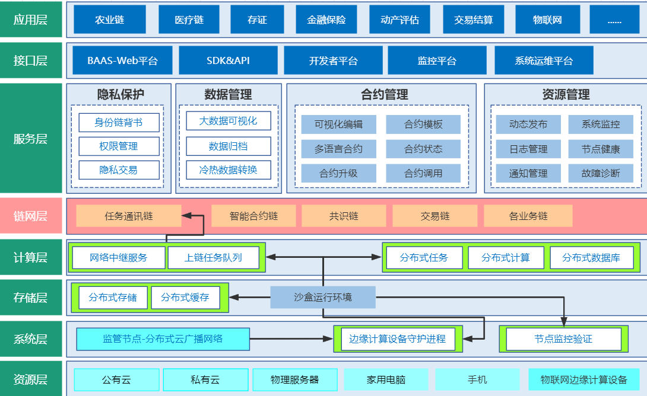

Figure 1 CNFS Technical Architecture

CNFS consists of more than one protocol, just like TCP/IP consists of a four-layer protocol stack model. It includes five protocols: storage layer protocol, distributed network resource management protocol, storage content retrieval protocol, distributed computing protocol and blockchain application management protocol. As shown in Figure 2

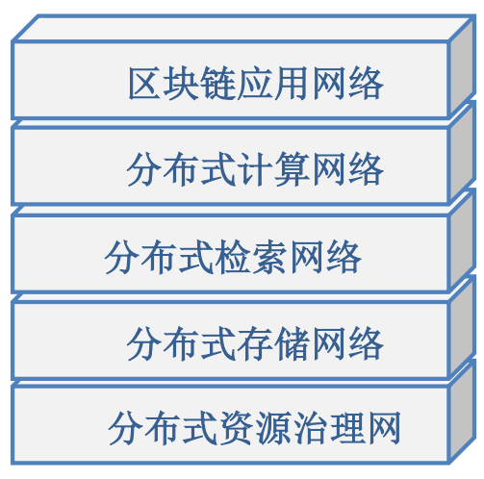

Figure 2 CNFS Five-layer Architecture

The CNFS resource management layer allocates the computing power of the whole network, removes unstable computing power according to algorithms, makes real-time statistics, reports adequate computing power, and provides solutions for the dynamic release and management of contract services. The supervisor node in the CNFS resource management layer scans the real-time operation status of the whole network, eliminates equipment with problems, improves the score of the equipment with good resource status, and ensures the network resources highly available all the time.

The distributed storage layer uses the distributed storage protocol to realize the distributed database, which is in physical distribution and logical unification, guarantees the data atomicity and consistency, and satisfies the distributed database of blockchain fragmentation extension. Moreover, the distributed database retrieves data based on the content hash, ensuring the authenticity and reliability of the distributed data and improving inspection and audit speed quality. The optimized distributed hash table technology is used to record the file's metadata to achieve the file addressing function, realizing the content-based addressing or data block based addressing in the distributed data network.

The distributed computing layer dynamically allocates computing tasks to the edge network nodes to realize distributed computing. It will dynamically select the computing nodes that meet the requirements of the neighboring nodes to form a temporary computing cluster and perform the computing tasks. The service providers will not need to maintain the computing nodes themselves or consider the node selection problem. Different services can share the same computing equipment, dramatically reducing the maintenance cost and increasing general efficiency.

The blockchain application management layer aims to realize the cross-chain interconnection of many heterogeneous blockchain applications and form a distributed blockchain application network with interconnection, interoperability and mutual trust based on massive data. Through multichain ecological consensus, the connection between decentralized blockchain platforms is realized, the atomicity of cross-chain operation is solved, and the value exchange of multichain ecology on the CNFS platform is realized. For different ecological applications, multiple Dapps are built based on the multichain blockchain structure to realize the trusted value exchange on the chain. It’s a trustful distributed application trading platform with a transparent transaction process, whole chain supervision, disintermediation, and data privacy protection. The central currency trusteeship is eliminated. The consensus mechanism of group supervision and management plan is adopted. The smart contract is executed automatically to form an autonomous community with independent value interaction.

* 1. Distributed Storage

Mimicry architecture for metadata services

Metadata node is a high-risk target in the distributed storage system, which is the preferred target for attackers regarding the difficulty of implementation and the benefits. Similarly, from the perspective of defenders, if we can protect metadata services through the CMD security mechanism, we can get the maximum-security benefits; In terms of protection cost, we need to pay extra cost and performance overhead for heterogeneous redundancy. Therefore, if metadata service is designated as pseudo protection boundary, it can significantly reduce the cost and the load pressure of agent and has better realizability. At the same time, for the protection of data nodes, the DHR structure could be optional. Based on existing block redundancy, heterogeneity is introduced to enhance the storage security of physical data blocks.

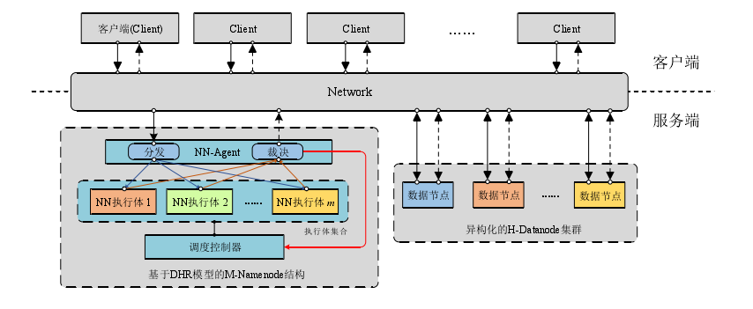

Figure 3 Mimic-HDFS Architecture and Relationship

CNFS lab designed Mimic-HDFS architecture for metadata services. To reduce the complexity of design and implementation while ensuring compatibility with the original system, Mimic-HDFS still uses the essential node functions and interaction process of HDFS, as shown in Figure 3.

Aiming at the security problems in the current distributed storage systems, we introduce a dynamic, heterogeneous and redundant security mechanism to enhance the system's defense capability against vulnerabilities and Backdoors. Firstly, we analyze the main threats and attack methods the distributed storage systems face, locates their "core weakness, " and proposes a specific security construction method based on the cost and effectiveness of protection.

* 1. Distributed Computing

2.3.1 Execute Tasks

The task pool consists of two tasks:

* System generated tasks
* User tasks. When users submit tasks to solve some problems, they will set the task reward

A small smart contract system is attached to any task to submit the contract and calculation results. Mining will get both task return and bookkeeping return.

A standard training task includes the following items:

* Training data. Datasets can be provided or customized
* Training script. Training methods come from standard deep learning models (RNN, CNN, LSTM, etc.) and other customized methods
* Training rewards. A.I. miners complete the training task, and the amount of reward needs to be predefined. The higher the rewards, the higher the training priority. The task system is stored on the integrated IPFS, which stores the algorithm and task after encryption. When the miner receives the calculation task, it will return its hardware parameters and download the calculation task and training dataset remotely. After the standard distributed TensorFlow is encapsulated, the appropriate redundant calculation is added to ensure the reliability of the calculation results.

2.3.2 Artificial Intelligence Miner

The computing power of a 1080Ti graphics card is 7514 GFLOP/zs. The calculation time of 30 iterations is 19 hours and 43 minutes using the Caffe framework to train 1.3 million image data of the GoogLeNet model on GTX 1080Ti. The cost time of six card parallel computing can be reduced to 3.5 hours.

Any GPU miner that supports CUDA (mainly NVIDIA Series graphics card) can integrate A.I. mining system. A.I. miner is preinstalled with standard artificial intelligence algorithms, such as CNN, RNN, DNN, and many other commonly used libraries, such as TensorFlow. The upgrade client integrated with the system can automatically update the A.I. preinstalled support library. The first batch of computers will mainly be preinstalled with Python 3.6 support library. The accounting client supporting Ethash is also included.

Three kinds of Income can be obtained from A.I. miners:

* Accounting income: the algorithm based on Equahash is well supported. But this part of Income is generally less than the Income of A.I. computing.
* A.I. computing income: A.I. computing income is an essential income source.
* IPFS Income: miners can start dual mining mode, which supports SIA, storj. IPFS can also be used to pay the data storage cost in A.I. computing process.

2.3.3 DAPP Development

Distributed computing plays a vital role in the development of DAPP. The Ethereum community names innovative contract-based applications DAPP (Decentralized Applications). DAPP's design goal is to pro the smart contracts with friendly interfaces and some additional functions, such as IPFS. DAPP can run on a centralized server that can interact with Ethereum nodes. For example, the famous etherdelta, EtherCAT and so on.

However, the current smart contract is not enough for the decentralized A.I. application (DAI App). Here are the reasons:

* Ethereum smart contract does not have A.I. computing modules
* EVM is a Turing complete virtual machine, but its consensus computing system only supports simple tasks, not complex A.I. computing
* Ethereum mining client does not support libraries required by A.I. computing

The operation of A.I. heavily depends on the support of various development libraries, and distributed computing is its primary task. A separate computing client can implement the support library for related computing tasks.

However, as a commercially available A.I. application, the ledger and payment function of Blockchain is still the core component of the system. And because of the scarcity of A.I. computing resources, sharing computing power will become a condition. Each user can rent computing power to complete their tasks. Each DAI App developer writes a standard smart contract according to their own needs.

* 1. Cross Cross-chain invocation

It’s a feasible Multichain scheme in CNFS. In CNFS architecture, files of different companies can be stored in other storage locations to achieve isolation.

In each storage location, there are three chains: transaction, file operation chain and file storage main chain. The main chain of file storage has many branch chains, and the branch chains are divided according to the file types. The file storage branch chain parallels the primary storage chain of a field. In this way, different files and metadata information can be stored in other branch chains to improve the efficiency of retrieval and classification. In addition to a storage location, transaction main chain and file operation main chain operate different storage locations. The two main chains rely on relay nodes for information exchange. The transaction branch and file operation branch of the file operation main chain in each storage location will be connected to two main chains, respectively. The file operation branch records the query, transfer and other operations of the file in the storage location, and the transaction branch records the token information. The multichain structure can be used to realize cross-domain token transaction and file operations. The file operation branch chain and file storage main chain in each storage location is also connected through relay nodes. When reading a file, the file operation branch verifies the file to the file storage main chain through the relay node and then executes and records the file operation. CNFS uses the characteristics of Multichain to divide files according to file types. It stores files of different companies in different storage locations to achieve domain isolation. Other storage locations can customize smart contracts to realize different storage logic.

* 1. Consensus Mechanism

At present, the mainstream blockchain consensus mechanisms are Proof of Work (POW), Proof of Stake (POS), Delegated Proof of Stake (DPOS) and so on. These algorithms require nodes joining the network to prove that they are more qualified to add a blockchain than other nodes. In the process of proof, colossal computing power is required, which results in a waste of power resources. Thus, the Oracle Proof of Work (OPoW) consensus mechanism is adopted in this architecture.

CNFS has developed and optimized the PoW consensus protocol to form an OPoW consensus based on Oracle. The consensus structure is shown in Figure 4. OPoW solves many existing problems such as the waste of computing power and unequal mining resources and realizes green mining, adequate storage and efficient computing. Each network node regularly reports the storage, CPU, memory, bandwidth and other software and hardware resources of the device to itself and the relay node. Its own running Oracle machine scores the nodes in small data analysis of IoT devices and records them in the public blockchain ledger. At regular intervals, multiple sets of devices are selected from the resource ledger according to consensus. The election and consensus execution of miner nodes are asynchronous processes. By judging the reliability of network resources based on Oracle, OPoW can be used to achieve consensus safely, reliably and efficiently.

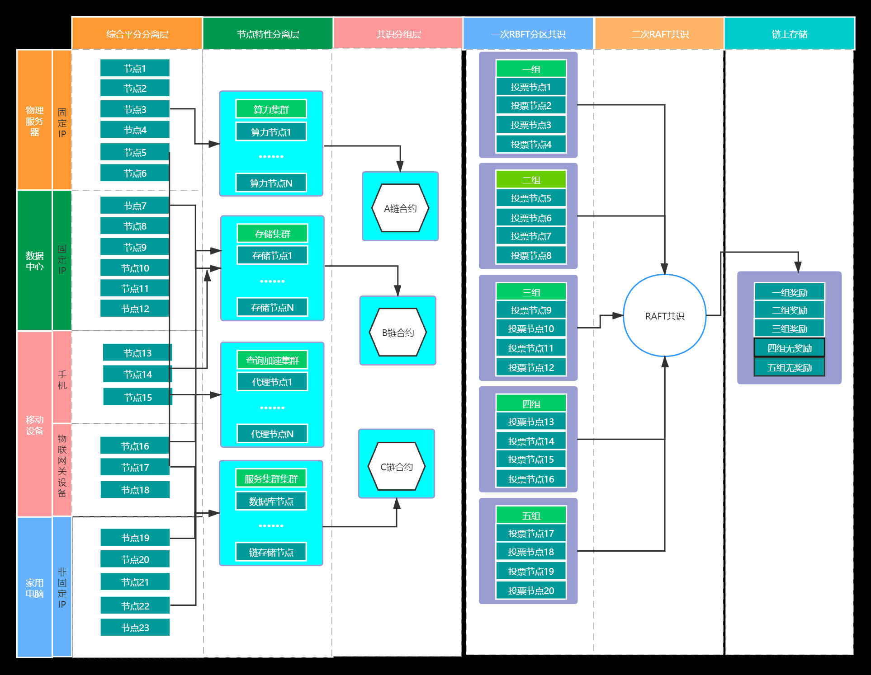

Figure 4 OPoW Consensus Architecture

This architecture is based on the reliable network resource execution environment determined by Oracle. It combines with RBFT (Robust Byzantine Tolerance) and Raft consensus algorithm and proposes the OPoW consensus mechanism based on the vision of controllable resources of the whole network. OPoW can achieve a safe and efficient consensus on reducing the waste of computing power and speeding up the block generation speed. It can effectively reach a consensus on the validity and consistency of block data in a decentralized and avoid the divergence phenomenon in the system.

03

Business Model

* 1. Token Mechanism

3.1.1 Mixed exponential mechanism

Traditional blockchain projects like bitcoin adopt token mechanisms based on a simple exponential decay model. This mechanism continuously reduces the reward parameters from the initial block reward, and often the number of contributors involved in the early stage is small, and the density is low. Therefore, in the early stage, participants will get many low-cost value tokens, while in the later stage, the block reward of participants is less.

According to this traditional exponential decay model, it will cause a short-term explosive power in the early stage, but because of the reward decay, it will harm the CNFS economy. Specifically, this will encourage early participants to invest in specific hardware to compete for block rewards by mining with encapsulated storage. However, after consuming these early block rewards, they will gradually leave, failing to form a fair competition environment and severe consequences to network security and ecosystems, such as hardware abandonment and user data loss. Meanwhile, due to the decrease of block rewards, new participants have little incentive to improve the network. It will also lead to the fact that most of the network subsidies are paid entirely based on time rather than the actual amount of storage.

To encourage storage and long-term storage investment consistency rather than just fast encapsulated storage, CNFS introduces the mixed exponential mechanism instead of the exponential decay model to maintain the value token. This mechanism can improve the block reward by increasing the total storage computing power on the network. In this way, the structure of the original exponential decay model can be retained, and it can be improved at the initial time of network startup to ensure that the block reward of CNFS is more matched with the utility provided by the whole network for users.

Specifically, in the mixed exponential mechanism, one part of the reward comes from the simple exponential decay mechanism, the other part comes from the network ecosystem. With this mechanism, CNFS mining will be more profitable. The simple exponential decay mechanism provides additional incentives for early miners and provides anti-vulnerability when the network is influenced. The Benchmark model will generate more tokens when the network accumulates more value. When the network can unlock more significant potential, the protocol will create more tokens to stimulate more transactions. This will promote the increase of network value and reduce the risk.

The protocol allocates less than 50% storage mining quota for simple decay mechanism and more than 50% storage mining quota for benchmark mechanism. A simple mechanism can provide reaction force and anti-vulnerability when the network is influenced. Benchmark mechanism can start with a small percentage of global storage today, then proliferate and get a higher but still reasonable proportion of global storage in the future.

Finally, it should be noted that although block rewards can encourage participation, they cannot be regarded as a resource that can be exploited and abused. This is a subsidy pool that benefits both the ecosystem and the participants, providing seeds and subsidies for the formation and growth of the network.

3.1.2 Token distribution

The distribution plans of CNFS token (CNX) are as follows: the limit is 10 billion CNX. In the allocation of genesis block of CNFS, 3.5% (350 million) of the total amount of CNX is allocated to funding usage, which is linearly released in two years, of which 2% (200 million pieces) is used for private offering, and 1.5% (150 million pieces) is used for public offering. All of the funds will be used for project R&D, ecosystem development and many other sectors; 0.5% (0.5 billion) is reserved for the initial stage of ecosystem construction, which is used to reward the contributors who are not clearly defined or mentioned in the whitepaper; 5% (500 million) of CNX are allocated to the laboratory team, which will be linearly released in four years; 6% (600 million) will be allocated to CNFS foundation, and this part will be released according to the six-year linear model; The remaining 85% (8.5 billion) were allocated to CNFS miners as mining rewards for their contribution like data storage services, maintaining Blockchain, distributing data, running contracts, etc. These rewards will support multiple types of mining, so this section will be broken down to cover different types of mining activities.

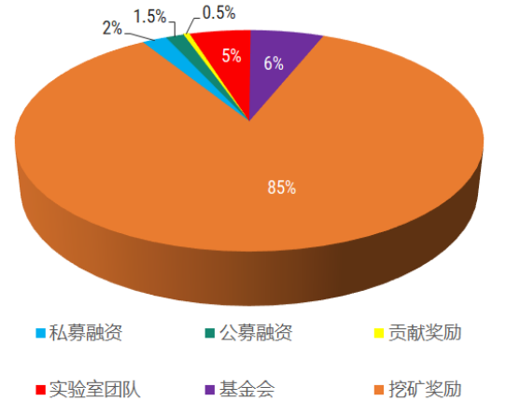

Figure 5 Token Distribution

3.1.3 Token Application Scenario

**Node qualification**

Any member who applies for the CNFS ecosystem obtains membership as the corresponding node needs to stake certain CNX tokens. Node members can obtain the essential services of the CNFS ecosystem, including the rights and interests of nodes with different levels and functions, such as technical support and supporting services for accessing the commercial network.

**Storage mining**

Storage miner is the only miner group with an incentive when the network launches. This was also the earliest group of miners, who were also responsible for maintaining the core functions of the protocol. Therefore, a considerable part of the CNX mining reward will be distributed to this group. This part of the reward is mainly issued by block reward, which is used to reward the maintenance of Blockchain, run contracts, and provide reliable storage services. This section will also cover early miner rewards, such as those at the space race, and other potential storage miner startup options, such as faucets.

**Mining conditions**

To participate in mining in the CNFS ecosystem and the corresponding hardware facilities involved in storage, it is necessary to stake the corresponding amount of CNX to obtain mining qualification, which is also one of the means to realize CNX deflation. Corresponding to different bandwidth storage facilities, one should stake the corresponding amount of CNX to meet the needs of mining conditions.

**Mining rewards**

To build a robust ecosystem, the CNFS ecosystem needs to ensure that all miners who participate in the ecosystem construction have incentives (such as search miners, maintenance miners and many others). To ensure that the network can provide incentives for miners, a part of CNX will be reserved for mining incentive reserves. In the future, the community can decide how to distribute these tokens through CNFS improvement proposals or similar decentralized decision-making methods. For example, communities can choose to set up incentives for retrieval mining and other mining activities. Like other blockchain networks and open-source projects, the CNFS network will continue to evolve, adapt, and overcome challenges in the future. These reserved tokens are used to provide more flexibility for future miners and the whole ecosystem. Other mining activities that have not been subsidized, such as search mining, are also critical to the CNFS economy. These mining activities need a higher proportion of mining rewards. Many years later, as the network evolves, the community can decide whether the reserve is sufficient and whether it needs to adjust the unearthed tokens.

**Asset trading**

In the CNFS ecosystem, CNX will be the only value carrier circulating in the global business system, including but not limited to the CNFS ecosystem, financial market, digital asset trading market and many other forms. CNX will be the value carrier circulating through the exchange of digital assets or the sale of fiat money in a legal way.

**Ecological fuel**

CNX is the value carrier of the CNFS ecosystem, and the consumption mechanism of CNX is a vital process to maintain the ecosystem. In addition to the CNX destroyed due to storage failure and consensus failure, some CNX is also eliminated as the network transaction fee for the computation and bandwidth in the payment chain, bringing long-term deflationary pressure to CNX. Usually, there is also a message packing priority fee. Instead of being burned, the packing priority fee is directly sent to the miner who packages the message.

**Community voting**

In line with the original intention of decentralizing the CNFS ecosystem to promote more CNX holders to participate in the construction of the network ecosystem fully, the CNFS foundation will establish a community and the voting mechanism to protect the management and discourse rights of the network ecosystem the network ecosystem the community members.

**Market value carrier**

The total value of the circulation of CNX is the total market value of CNX. Many communities use different calculation methods to estimate the market value of digital currency and tokens. However, the most reasonable way to calculate the market value is the supply of CNX (total circulation supply tokens). Using other methods of significant calculation amounts is likely to be a false exaggeration and should not be believed.

* 1. Ecological Community

3.2.1 CNFS Application Scenario

Blockchain has the characteristics of decentralization, P2P transmission, transparency, traceability, non-tampering, data, etc. It’s to solve some pain points of existing business and realize the innovation of the business model. Aiming at the difficulties of distributed data storage, the CNFS laboratory team provides its own soon through the decentralized storage network based on CNFS protocol. Moreover, Blockchain will also play an essential role in other existing or potential application scenarios, such as medical, construction and energy. The ecological panorama of CNFS is shown in Figure 6

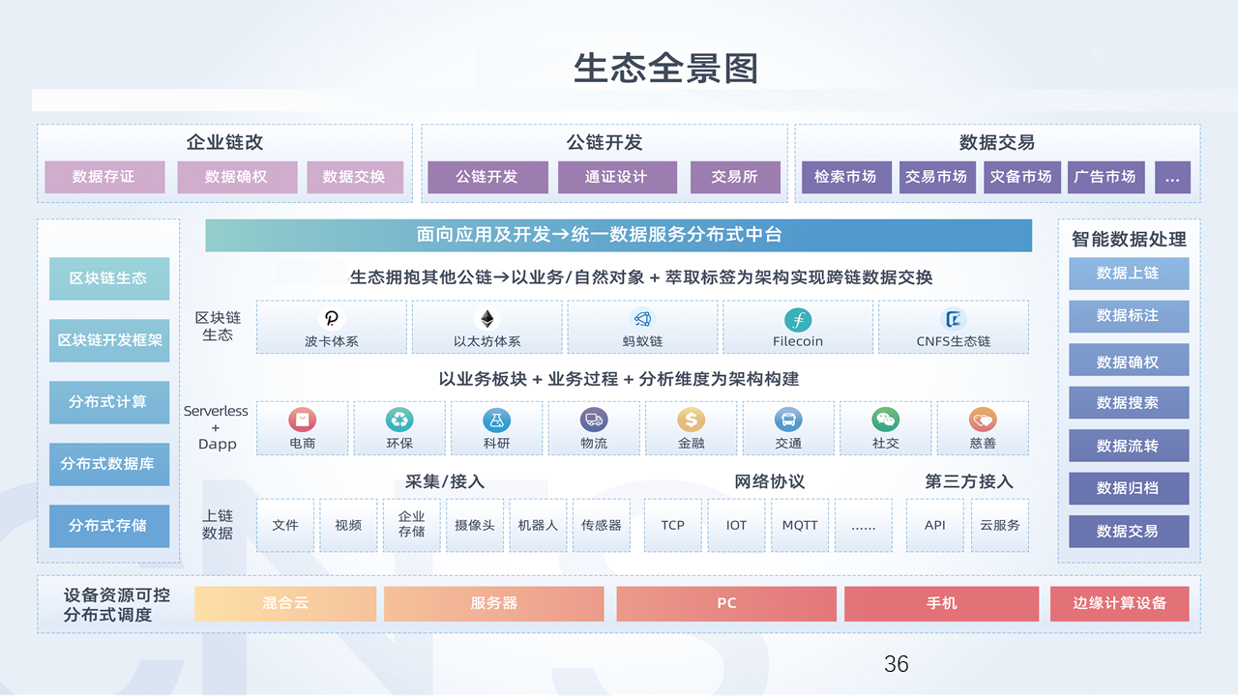

Figure 6 The ecological panorama of CNFS

(1) Architecture

The construction industry should comprehensively upgrade the informatization and actively explore the sharing and exchange of data, break the information gap or isolated island, realize cross-functional business linkage, shorten the project progress, and improve the project quality and economic benefits. With the emergence of building information modelling (BIM) and other technologies, all participants in the design and construction of the construction industry can cooperate in the whole process on a common platform so that the original scattered construction industry, its production, operation, and management level can also achieve effective integration, and gradually become the trend of the construction industry.

The architecture industry should comprehensively upgrade itself in the informatization era and actively explore new ways of data sharing and exchange to break the information gap, realize cross-functional business coordination, shorten the project progress, and improve the project quality and economic benefits. With the emergence of building information modelling (BIM) and other technologies, all participants in the design and construction of the architecture industry can cooperate in the whole process on a universal platform. So, the production, operation and management level of previous independent groups or individuals can also achieve effective integration and gradually become the trend of the architecture industry.

Although the architecture industry has gained many improvements, it is undeniable that there are still significant shortcomings and potential risks. In the current market, there are such phenomena as cross-regional information is not transparent, resources cannot be shared, illegal bidding, credit and regulatory mechanism failure, which hinder enterprises' market development. A lot of information and data will be generated in project implementation, such as contracts, drawings, change orders, on-site measurement sheets, etc. These electronic materials are easy to be modified in the iterative forwarding process. Once there is a problem, it is often difficult to find the source and investigate the responsibility.

CNFS is integrated with digital technology, distributed storage of massive BIM data. It uses a digital way to create a virtual model of physical entities. With the help of data to simulate the behavior of physical entities in the real environment, virtual real interaction feedback, data fusion analysis, decision-making iterative optimization, and other means, the new capabilities for physical entities are well expanded. It becomes the key to solve the development problems of the architecture industry.

It is necessary to evaluate the bidding enterprise's qualification, personnel qualification, and credit in the bidding process. Traditionally, detailed prequalification documents need to be prepared, and the bidder also needs to pay a lot of time and resources to review the qualification documents. Integrating blockchain technology into the credit platform of the construction industry can well improve the prequalification and formal bidding competition of bidding activities, ensure the process is open and transparent, and prevent vicious competition and human intervention. In construction management, blockchain technology can reduce the confirmation time of the authenticity of construction documents, facilitate the collection and storage of various construction data, track the Data on the chain, and avoid malicious tampering of information by others.

（2）Energy

With the advancement of the energy revolution, energy is gradually transforming to clean and distributed. The proportion of renewable distributed energy with high efficiency, flexible operation and sound economy in the energy system is gradually increasing. It has become an essential source of power generation. Green energy may become a strategic highland for developed countries in the world. Unlike traditional energy trading, distributed energy trading has massive participants, a small amount, scattered location, etc. Moreover, the frequency of energy trading is very high, which will improve the operation cost of the transaction. In addition, there are some problems in energy trading, such as the difficulty of information authenticity verification, data sharing, high transaction cost, low collaboration efficiency and data privacy protection.

CNFS ecosystem can create a more visible, more credible and more reliable regulatory environment to solve the problems of carbon trading, such as complex accounting, supervision and assessment due to multiple industries of carbon emission subjects, inconsistent carbon emission evaluation and analysis standards, imperfect carbon emission market mechanism and other factors.

CNFS uses blockchain technology to coordinate carbon trading entities, trading institutions, and governments to build a flexible and interactive carbon asset trading mode. It realizes the chain storage and reliable sharing application of the whole process data of carbon trading from proper emission acquisition, trading, circulation to transaction verification and statistics. Thus, the carbon emission quota can be traded under the condition of "visible to all". And it builds a system of all parts and the whole process to promote the transparency and orderliness of the global carbon emission trading market.

CNFS ecosystem creates a safer, more efficient and more economic market environment for carbon trading. Carrying out efficient and economical carbon trading activities will strongly stimulate the enthusiasm of crucial carbon emission enterprises to participate in market trading, encourage enterprises to carry out technological innovation and upgrade the industrial structure, and promote enterprises to save energy and reduce emissions from the source. We should give full play to the technical characteristics of Blockchain, such as distributed ledger and traceability, effectively aggregate the upstream and downstream carbon quota trading information of low-carbon industrial chain, break through the data island of each part of carbon trading, apply the blockchain smart contract to support the carbon trading service of bilateral and listing equality. Meanwhile, with the help of blockchain signature technology, it can ensure that the trading data can be traced and can’t be tampered with. Also, it provides the authenticity, safety and efficiency of carbon trading activities from every part and builds a safe and efficient business environment for the carbon trading market.

（3）Medical

The medical industry has unique requirements for the privacy protection of patients. With the popularity of cloud storage and mobile health devices, data recording and sharing have become more common in the Internet era. The risk of malicious attacks and the risk of privacy information leakage during sharing is also increasing. Patients usually go to multiple hospitals, so sharing medical and health information is worthy of attention.

Blockchain technology can be used to support access control, data sharing and medical activity audit tracking management. The medical system based on blockchain technology can improve the security and reliability of patient data so that patients can control and share their medical data records. The medical system integrated into the Blockchain can also help integrate patient data and realize the sharing of medical record information between different medical institutions. In addition, Blockchain has the characteristics of data tampering, timestamp and information traceability, which can be well applied to the medical anti-counterfeiting traceability system, making the traceability function of the system better. It is worth noting that the current medical data on the chain is the main direction of medical enterprises, such as the liver health status data written into the Blockchain, which will help the medical industry to develop better.

(4) Vehicle-to-everything

In recent years, with the gradual development of the smart city and smart transportation, Vehicle-to-everything has been widely concerned. The Vehicle-to-everything can generate a large number of diverse data through advanced onboard equipment. Vehicles collect and share data to improve driving safety and achieve better service quality of its system. For example, the car can automatically determine the driving plan by receiving the event, road condition and other information broadcast by other vehicles.

However, there are serious security and privacy challenges in data sharing on the Internet of vehicles. Users may be reluctant to upload vehicle data to the network for privacy protection and fear a single point of failure in centralized management. Although P2P data sharing can solve centralized management architecture, it still faces illegal data access and security in a distributed architecture. If malicious vehicles are spreading false information, it will cause severe interference to standard vehicles and even threaten the personal safety of drivers.

CNFS ecosystem carries a large amount of Internet of vehicles data, enabling the Blockchain to the Internet of vehicles. Vehicle failure and traffic accidents will be permanently recorded in the Blockchain due to the features of Blockchain, which can solidify the evidence and solve the integrity problem of vehicle data. It can be accessed, including auto repair, auto parts, vehicle management, auto manufacturer, car rental, insurance, etc. The smart contract can automatically execute the transaction and record the complete lifecycle of the vehicle.

It can improve the safety of driving and the efficiency of service provider management by sharing the data information protected by the Blockchain; the data rendering is completed in advance between vehicles, between vehicles and people, between vehicles and service providers, etc. By collecting data inside and outside the vehicle during driving, users have their data, which can be shared with the third party (such as the second-hand trading market, insurance industry, etc.) to obtain integrity data value and user profit.

(5) A.I. computing power

With the exponential development of big data, the Internet of things, sensors and other technology fields in the past few years, artificial intelligence applications have begun to explode. A.I. applications like face recognition and voice interaction technology have started to influence our lives. Artificial intelligence applications intelligence needs to train the model by the neural network, which requires many computing resources. More Data needs a longer training time, which is highly disadvantageous to the iterative updating of products and will cause manufacturers to invest a lot of money in purchasing hardware resources such as GPU. After the product service launches, the model still needs to be trained, but the user's access period or frequency will also change from time to time. If many computing resources are purchased at one time, there will be a lot of idle resources. Artificial intelligence should obtain high-quality Data continuously, but a lot of data involves user privacy. Users are unwilling to disclose their private data, which limits the development of companies.

CNFS team provides a new solution for the above challenges. A distributed A.I. computing platform based on blockchain technology is designed to realize the flexible distribution of computing power, reduce the computing cost of enterprises and individuals, and protect the data privacy of sellers through anonymous nodes on the chain.

3.2.2 CNFS Ecological Applications

(1) CNFs browser

The developing path to truly decentralized networks is very hard. For more than 30 years, the browser has always existed as a client - but in the evolution of the P2P system, the browser, as a participant, is both a client and a server. Those web browser developers and web standards organizations have not designed their systems that support P2P protocol. Integrating CNFS in the browser is to simplify the access to the HTTP gateway of CNFS, to build a bridge between hundreds of millions of people in the traditional network and the content of the distributed network. To sum, users can directly access the Data on the CNFS network through a regular browser, which is a client and has the same function as a server as a native CNFS node. This will simplify the process of user participation and promote the large-scale application of CNFS.

(2) Data exchange platform

The data exchange platform is based on distributed storage. It builds the business closed loop through distributed storage network and CNFS platform and realizes the marketization of business data files. The e-commerce (customer to customer, C2C) transaction between individuals is realized.

It allows people to trade digital goods (e.g., art, code, video, music) to generate revenue from their data. All data are stored in the CNFS platform safely so that transactions can be carried out without the participation of any third party, and the minimum cost can be ensured. We are building a license-free P2P data exchange platform for data licensing, exchange and storage services.

04

Core Advantages

**High security** —— The five-layer protocol stack of CNFS provides security protection for data generation to data acquisition, data storage and data application. It adopts the most advanced data encryption technology to realize reliable security protection with 0% cracking rate of existing technology.

**Privacy protection** —— CNFS five-layer protocol stack provides full lifecycle data hash encryption and encryption repair technology for data, ensuring anti-collision and protecting data integrity of 99.999%.

**Fault tolerance** —— Decentralized systems are less likely to fail unexpectedly because they rely on many independent components that are unlikely to fall simultaneously.

**Optimized incentive** —— The economic model is designed by a professional team to provide users with a safe and secure income model.

**Anti-centralization** —— According to the optimized Byzantine algorithm, more than 51% of the data nodes are under control to achieve anti-collision.

**Massive Data** —— In the initial stage of CNFS ecological network construction, the world's first open network storage of medical data has been achieved. The data pool includes massive high-quality data in agriculture, architecture, Internet of vehicles, finance and many other fields, providing valuable data capital for distributed computing.

05

Routines

To ensure the decentralization, enhance the security of customer assets and the credibility of CNFS ecosystem. It will carry out project development and ecological construction under the following planning path and gradually realize the diversified development of the whole ecosystem. Its development process and planning routines are as follows:

**CNFS Roadmap:**

Form a project team in 2019 to investigate the future development of distributed storage and distributed computing market

2020, Q1

● CNFS project development begins

2020, Q2

● Launch CNFS global node for data test of 4 continents

2020, Q3

● The first application of CNFS launches

2020, Q4

● As the next-generation Internet infrastructure of Web3.0, CNFS starts the implementation of multi-node and storage applications

2021, Q1

CNFs officially launches Silicon Valley Laboratory

CNFS provides data application on Blockchain for carbon neutral

2021, Q2

CNFS officially launches Hong Kong Laboratory

CNFS starts the medical image data storage test

2021, Q3

●   CNFS testnet launches

●   Developers.cnfs.com launches

● Global space race starts (on testnet)

2021, Q4

●   CNFS mainnet launches

●   CNFS client launches

2021, Q4

●   CNFS releases the complete developer kit

●   CNFS releases the network accelerator

●   Develops CNFS global community

2021, Q4

●   Releases v1.0.2 beta version of CNFS mainnet and integrated into CNX token economy

2022, Q1

●   Releases an easy-to-use CNFS host operation interface

●   Integrated to Windows client

●   Attracts developers to build and develop on CNFS network.

2022, Q2

●   Releases easy-to-use CNFS renter operation interface

●   Renter contract modification feature

●   Help partners deploy CNFS technology

06

Disclaimers

As a technical whitepaper, this paper introduces the current and future development of CNFS platform and ecosystem. This paper is for reference only and should not be used as a statement of future intention. Unless otherwise specified, the products and innovations proposed herein are currently under development. CNSs makes no warranty or statement regarding the successful development of such technology and innovation or the realization of any other activities described herein. And to the extent permitted by law, it assumes no warranty implied by law or otherwise. No one should rely on the content of this document or any inference drawn from it to make decisions, including any interaction with CNFS or the technologies mentioned herein. CNFS shall not be liable for any loss or damage (whether foreseeable or not) caused by individuals relying on any information or opinions related to CNFS, information or statements about CNFS platform and ecosystem contained in this white paper, or information related to any further consultation. The information contained in this white paper is derived from information that CNFS considers to be obtained from trusted sources and reflects the information truthfully. However, CNFS does not guarantee the accuracy, completeness, or applicability of the above information. You or any of your employees, creditors, security holders or other interest holders or any other person shall not rely on the information or the rights or conferred by the information. Any opinions expressed in this whitepaper reflect the current judgment of the author and do not necessarily represent the opinions of CNFS laboratory. Opinions reflected in this article are subject to change without prior notice. CNFS has no obligation to modify, amend or update this document or otherwise notify readers of any change or subsequent error in any matter or any opinion, investment, forecast or estimate described herein. CNFS and its employees shall not be liable for any personal loss caused by any express or implied statement, opinion or information arising from the content or omission of this white paper. Neither CNFS nor its consultants independently verify any information, including forecasts, prospects and forecasts contained herein. Despite our best efforts to ensure the accuracy of the factual statements set forth herein, all estimates, forecasts, prospects, expressions of opinion and other subjective judgments set forth herein are based on assumptions deemed reasonable as of the date of this document and shall not be construed as statements of impending events. Any plan or forecast mentioned in this article may not be realized due to a variety of risk factors, including but not limited to technology development, legal or regulatory risk, market fluctuation, sector change, enterprise behavior or lack of complete and accurate information. Each reader relies on his knowledge, investigation, judgment, and evaluation to confirm the accuracy and integrity of the information. Without the prior written consent of CNFS, no individual may redistribute, copy, or transfer the contents of this article to any other individual or publish it in part or whole for any purpose. By accessing this whitepaper, readers of this white paper agree to be bound by the above restrictions.